April 28, 2026

Dear Pro-Family Friends,
We are thrilled to announce that IFI is partnering with our good friends at One Nation Under God Foundation (ONUG) to host and promote their annual Freedom Night event, which will be held at Belvedere Banquets in Elk Grove Village on the evening of July 30, 2026.
This year’s main attraction will be Dr. William Lile, who is known nationwide as “The Pro-Life Doc.” He is a board-certified OB/GYN, former department chair, and founder of the Pro-Life Doc ministry.
In 1999, he took over Pensacola’s largest abortion provider, and on day one, ended all abortion services and referrals. Since then, he’s been on a mission to educate and inspire, using his medical expertise and biblical convictions to defend the lives of the unborn.
Dr. Lile specializes in diagnosing and treating complex conditions before birth. From performing fetal heart surgeries to administering blood transfusions to unborn babies, his work presents a powerful and undeniable truth that these unborn children are patients who deserve the same rights and protections as anyone else.
Through powerful visuals, real medical knowledge, and unapologetic biblical truth, Dr. Lile speaks across the country at churches, schools, and pregnancy resource centers, equipping others to stand boldly for life. He’s also the creator of the Pro-Life Doc Curriculum—an 8-module educational series that features stunning medical animations, expert commentary, and interactive workbook content.
Dr. Lile’s message is clear, hopeful, and deeply compelling: a patient is a person, no matter how small—and every life is made in the image of God. Learn more about Dr. Lile at https://www.prolifedoc.org.
We hope you will be able to join us for this night of fellowship and encouragement, as we co-host this event we are calling, “Freedom for the Unborn.”
Blessings,
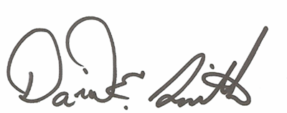
David E. Smith, Executive Director
Illinois Family Institute

