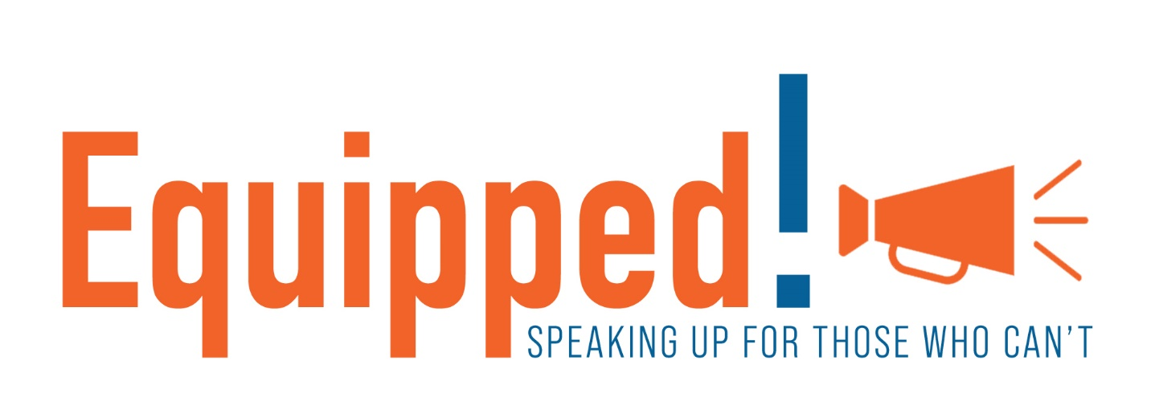

***Equipped!*** is a pro-life education project of Illinois Family Institute and Southside Pregnancy Center, that equips people to speak up for the preborn. Please consider how your church, Christian school or homeschool group can benefit from these presentations.

**Teaching our children to love life:***Kindergarten-Grade 6*

***JESUS LOVES THE LITTLE CHILDREN***

*Jesus Loves the Little Children*is an age-appropriate introduction to the humanity of preborn children. It focuses on the many ways Scripture proclaims life as well as the different stages of preborn life. Children get to hold fetal models at various stages of development. In addition, they see 3D illustrations of preborn babies at additional stages of development. Children leave with a small fetal model and the knowledge that Jesus does love ALL the little children – born and preborn. Great for Christian elementary schools and homeschool groups, and churches – Sunday school, children’s church, VBS, Bible clubs.

**Telling preteens, teens and adults the truth about abortion:***Grades 6-12****,*** *Adults*

***MAKING THE CASE FOR LIFE***

This three-part series, *Making the Case for Life,* is the antidote to the misinformation youth and adults receive from the abortion industry (and their allies) dozens of times every day. Between school, music, and other media, we receive a steady stream of lies about the abortion issue and the humanity of the preborn. *Making the Case for Life* will provide truth and strategies to counter these lies. Learn how science and Scripture can make the case for life independently, and much, much more! This presentation is a must-see for every youth and adult: pro-life, questioning, and even pro-choice. Q&As are included as time permits. Great for junior and senior high Christian schools and homeschool groups, church youth groups and adult classes.

**Part 1: Preborn – *What Is It?***

Learn about the stages of development of the preborn, their humanity and personhood. Learn how to respond to claims that the preborn is the mother’s body and that men should not have a say about the preborn.

**Part 2: Abortion – *What Happens?***

Learn about abortion procedures and how they impact not only the preborn, but the mother and others also. Learn The Success Sequence to avoid poverty and pre-marital pregnancy.

**Part 3: Circumstances and Values** - ***Where do YOU stand?***

Learn about the hard cases, resources during and after pregnancy, post-abortion resources, and how to promote life.

**Deepening your understanding of the pro-life movement:**

***HOW TO BE PRO-LIFE IN TODAY’S CULTURE:  
DIVERSE PRO-LIFE RESOURCES***

This annotated list provides an in-depth overview of the abortion issue, how it is affecting our world, and how to provide real help to women considering abortion. It includes the topics below. To download the annotated list, click the orange box below: THE RESOURCE LIST. Updates are noted by more current dates.

Pregnancy Resource Centers and Other Pregnancy Support

Abortion – General Information and Abortion Pill (Mifepristone/RU-486) Reversal

Impact of Abortion on Mothers and Others; Post-Abortion Healing

Adoption

Pro-Life Defense – Books, Videos, and Websites

The “Hard” Cases – Rape, Down Syndrome and Terminal Fetal Diagnoses

Resources for and about Children

Demonstrating the Humanity of the Preborn Baby

National and State Pro-Life Organizations

Abortion Survivors

Abortion Workers Become Pro-Life and Leave Their Clinics

How Churches Can Provide Support

Miscellaneous Resources

Ongoing and Upcoming Releases

[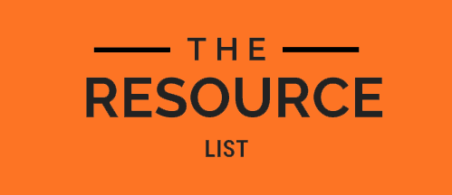](https://illinoisfamily.org/wp-content/uploads/2024/07/Pro-Life-Resources-7-17-24.docx)

For more information and to schedule a presentation, please contact us!

Evelyn Stenzel, Pro-Life Educator

[s.evelyn@illinoisfamily.org](mailto:s.evelyn@illinoisfamily.org)  
(708) 781-9328

Illinois Family Institute  
P.O. Box 876  
Tinley Park, IL  60477

**EquippedForLife.net**